Sound Configuration in 1135 Meyer Classroom
Written by Abbas Ahmadi (abahmadi@ucdavis.edu) January 16, 2013
To configure the speakers in 1135 Meyer Classroom, follow these steps:
- Turn on the built-in computer.
- Make sure the sound cable is plugged in the headset port in front of computer in. If it is not plugged correctly, then the computer sound will not be sent to the ceiling mounted speakers.
- On the Projector Control Panel, turn on the projector and set the volume at its mid-point.
If the projector is not on, then the ceiling mounted speakers are not operational and you will not hear any sound.
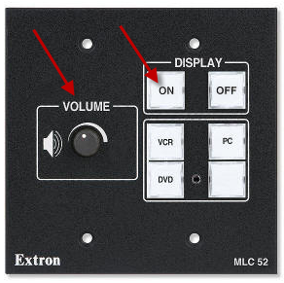
- Locate the speaker icon on the windows bar at the left lower corner.
- Right click on the speaker icon. A menu appears.
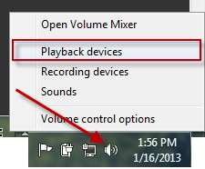
- Select the “Playback devices” option. A dialog box appears. Select the “Playback” tab.:
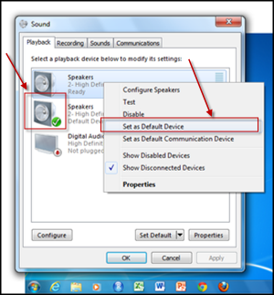
- You must see a green check mark next to the second speaker.
- If not, right click on the second speaker icon. A menu appears.
- Select the “set as Default Device” option. A green check mark appears next to the second speaker.
- Select the “Sounds” tab to test the sounds:
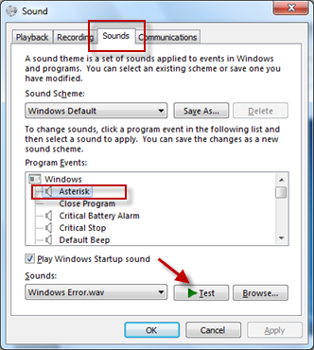
- Highlight the “Asterisk” entry in the list and click the “Test” button. You must hear the sound from the ceiling mounted speaker.

